mdg lEDCLOCK (Model 1)

QUICKSTART GUIDE v1.2 12-2021

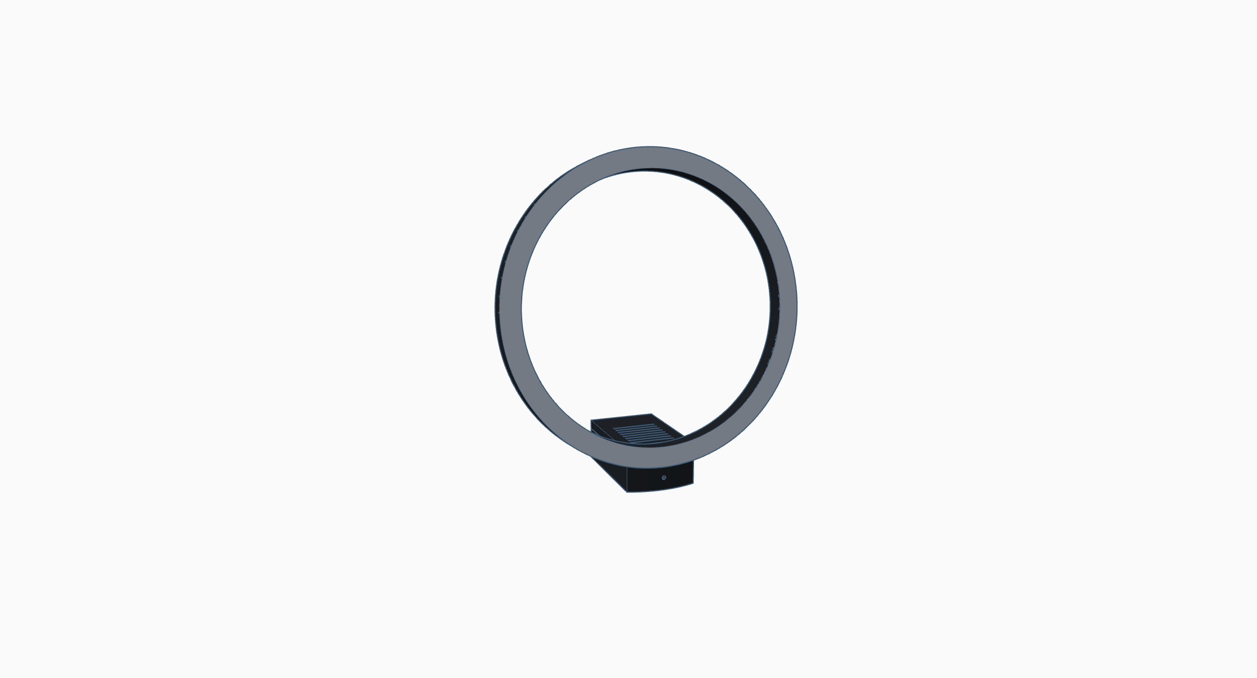

# Index

1 Index 2

2 Introduction 3

3 Setup your clock 4

3.1 Connecting to the clock 4

3.2 Setup your clock 5

4 Using your clock 6

4.1 Connecting to the clock 6

4.2 Create different clock displays 7

4.3 Change display schedules 8

# Introduction

First of all thank you for buying this handmade clock which is designed and created in a small workshop in the Netherlands.

I hope you have much fun using this clock!

How to get help

If you have any problems with this clock, please leave us a message at [support@mdg-design.nl](mailto:support@mdg-design.nl) and we will try to help you out.

A word of caution

The body of the clock is made on a 3D-printer with PLA plastic. PLA has a melting temperature of about 60C/140F. Please don’t leave the clock in a car on a hot summer day, or put it next to a heat source. This may deform or permanently damage your clock.

# Setup your clock

Power up your clock by connecting a micro USB cable1 to an USB 5V power source1 with an output of **at least** **1A**. Most phone and tablet USB chargers should work, there is no risk in damaging the clock if an USB charger is used with an output of less than 1A but the clock won’t function correctly.

When the clock is powered on, minutes 0 to 29 will light up white and minute 30 red. This will take about 30 seconds. The red light means that there is no working Wi-Fi connection. Follow the steps in 3.1 to connect to and configure your clock.

Note: *5 seconds after the red light the clock starts running but of course not on time.*

1 Not included

## Connecting to the clock

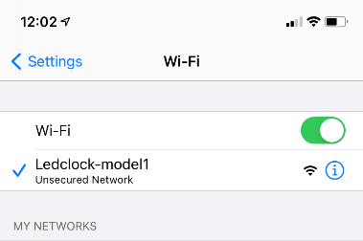When the clock cannot connect to a Wi-Fi network, or the clock is not configured, the clock will start a Wi-Fi network with the   
SSID **‘MDG-Ledclock1’**. Connect to this Wi-Fi network from your mobile phone or pc, the Wi-Fi key for this network can be found on the bottom of the clock. Note: *do not select the option to auto connect to this network.*

When you have a connection to the Wi-Fi network **‘MDG-Ledclock1’** open a browser on the device that has a connection with the Wi-Fi network **‘MDG-Ledclock1’** and go to the following URL: <http://192.168.4.1>  
  
After a couple of seconds the page as shown in below picture should appear. Open the settings page and follow the instructions in 3.2 tot setup your clock.

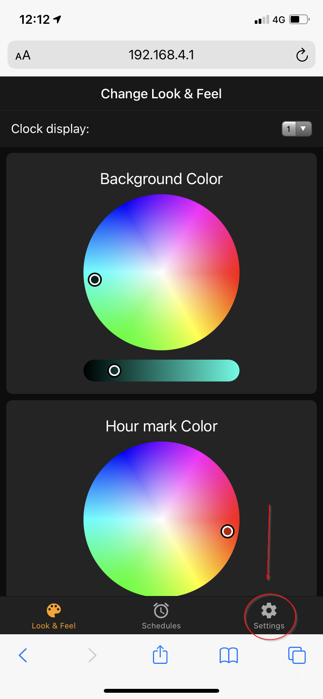

## Setup your clock

Press the Scan Networks button (1) and wait until a list of Wi-Fi networks appears. Select your Wi-Fi network and type your Wi-Fi password.

Select your time zone (2) and press the Save & Reboot button. Wait until you see the clock running with the correct time and continue to chapter 4

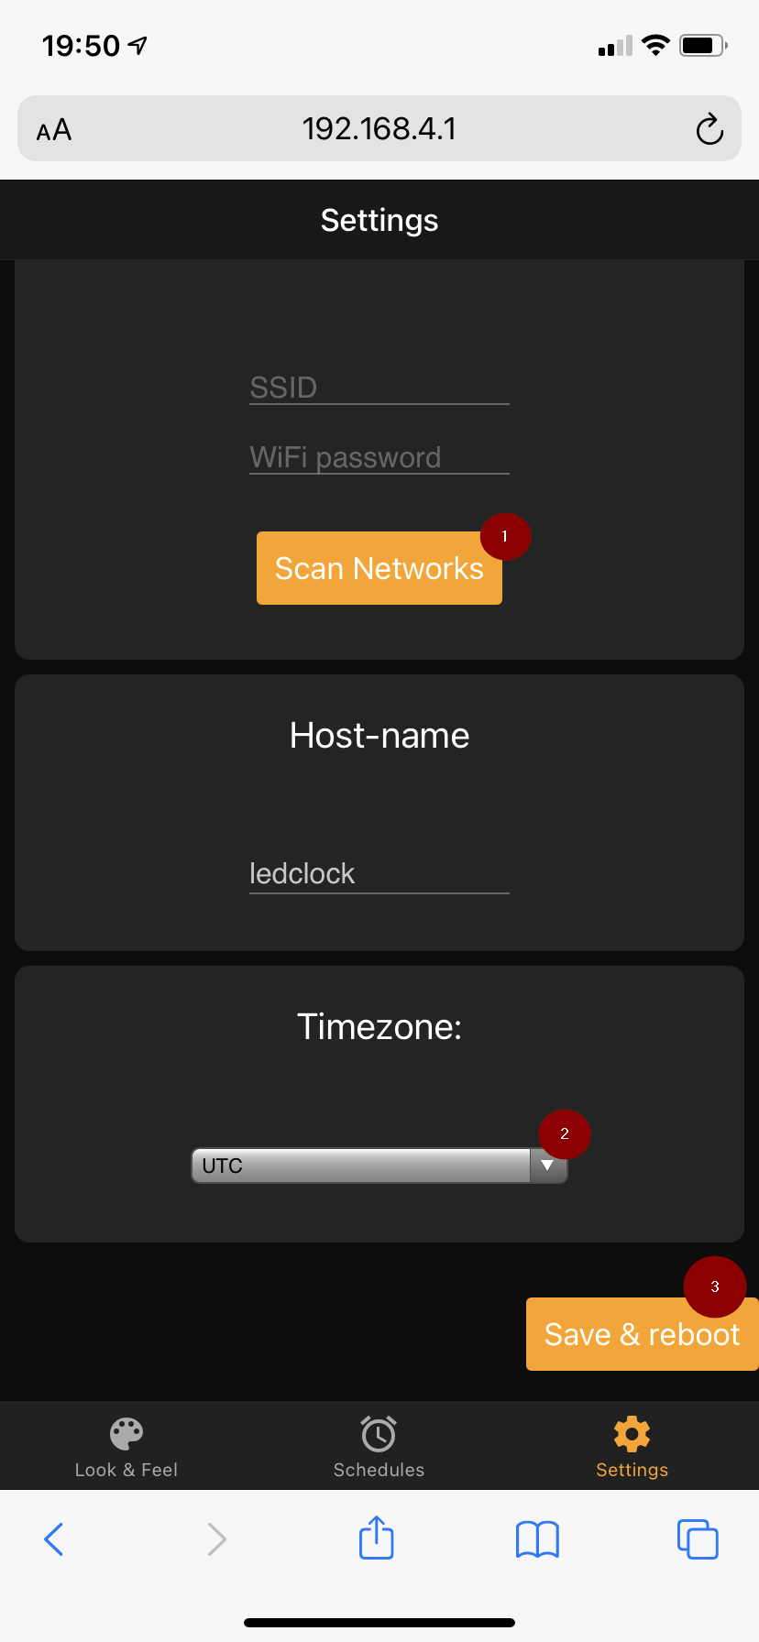

*Optional* When needed (for example when you have multiple MDG-clocks) you can change the hostname of the clock. When changing the hostname, make sure to only use numbers and letters. Also take a note of the hostname because you need it to connect to the clock.*

# Using your clock

This chapter describes how you can connect to the clock, how to create different clock displays and how to create schedules to change the clock display after you have setup the clock as described in chapter 3

## Connecting to the clock

Open a web browser and connect to <http://ledclock.local>, after some time the below interface should appear1.

*1: Make sure you are disconnected from the clock’s Wi-fi network and are connected to you own Wi-Fi network. If you changed the hostname as shown in 3.2, please use this to connect to the clock for example* [*http://yourhostname.local*](http://yourhostname.local)

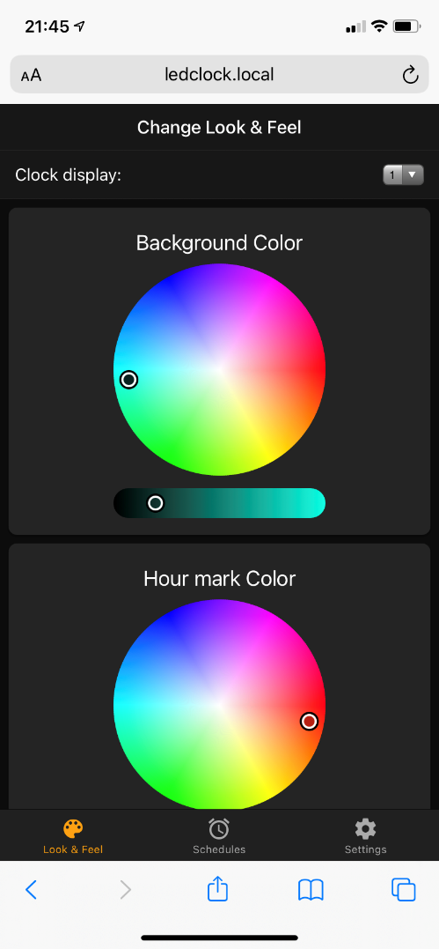

When above connection method doesn’t work, lookup the clock’s IP-address in your router or DHCP server. When you have found the IP-address of the clock, connect to it with the URL [http://*x.x.x.x*](http://x.x.x.x) where *x.x.x.x* is the IP-address of your clock.

## Create different clock displays

You can create 8 different clock displays and store them in the clock. First select a clock display number, change the colors and settings like auto brightness the way you want them and press the save button.

Note: *Out of the box all 8 position have the same default display colors (blue background, red hours marks and white hour, minute and second hand)*

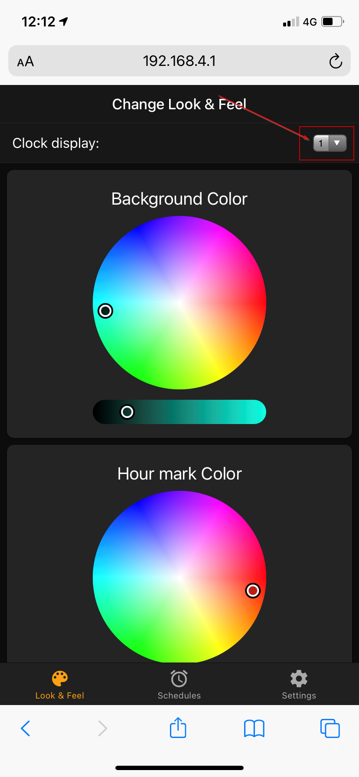

## Change display schedules

It is possible to change the clock display at specific times. For example: you can have a bright colorful clock display during the day and a very dim display during the night.

To create a schedule open the *Schedules* tab and click on one of the schedules. Select the time (1) and display number*(2) (one of the displays you created in 4.2*) and make sure the active switch (3) is on. You can create a maximum of 12 schedules. If you like to disable a specific schedule set the active switch to off (3).

